Table of Contents
(Page links take you to the website pages)

Section 3: You are in a [shudder] Situation of Uncertainty -- What Now?

Assess the risk of crossing
Page 1: Assess the risk of crossing
Page 2: Who has the right of way here? -- pedestrian / white cane laws
Page 3: How likely will I be surprised by an approaching vehicle?
Page 4: How likely is it that the unexpected vehicle will hit me?
Page 5:If I am hit, how likely will I be seriously injured or killed? ?
Page 6: Assess the Risk of the Crossing: Putting it all together! - Risk Analysis Checklist

Making a decision
Page 7: Is the crossing safe enough?
Page 8: Decide whether the risk is acceptable - considerations
Page 9: Decide whether the risk is acceptable

Consider alternatives
Page 10: Consider alternatives when the risk of crossing is not acceptable/preferable
Page 11: Alternatives When Crossing is Too Risky
Page 12: Alternatives: Environmental Modifications to Improve Crossings with No Traffic Control
Page 13: Want to apply this to real situations?
Page 14: Review

Please note that the links inserted throughout the text are NOT necessary,
they are meant only for those who want to know more.
Section 3: You are in a [shudder] Situation of Uncertainty . . . What Now?

When you find yourself at a crossing in a Situation of Uncertainty, what should you do? What CAN you do?
You
- First ASSESS the risk of the crossing.
- Then DECIDE whether the risk is acceptable.
- If the risk is not acceptable, then CONSIDER ALTERNATIVES.

This section will cover each of these issues, one at a time, and then provide a checklist with some practice to help you put it all together.
Deaf-Blind Students
At all crossings, including driveways and entrances, deaf-blind travelers are in a Situation of Uncertainty more often than other travelers. Thus it is even more important that they be able to assess the risks of crossings, make informed decisions, and implement alternatives.
In addition to understanding the information covered in this section, deaf-blind students need to know how to get the information that is necessary to assess the risks of crossing -- if you want more information and ideas about this you can click here (you will be leaving the Self-Study Guide).

Page 1 of 14
Assess the Risk of the Crossing
When you find yourself in a Situation of Uncertainty, your first step is to assess the risk of crossing there in that situation. Because there may be approaching vehicles with drivers who would have to slow down or even stop to avoid hitting you, in order to assess the risk of crossing there you need to find out:
- "who has the right of way here?"
- "how likely is it that I am going to be surprised by an approaching vehicle that could reach me during my crossing?"
- "if I am surprised with an unexpected vehicle, how likely is it that it will hit me?"
- "if a vehicle does hit me, how likely is it that I'll be serious injured or killed?"
We will look at each of these issues in the next few pages.
Risks can vary!
As we've said before, it is important to note that we are analyzing SITUATIONS, not crossings. The factors that affect the likelihood of being surprised and then hit by a vehicle and seriously injured or killed can vary a LOT at any crossing (we'll discuss this later).
So whenever you analyze the risks of crossing, you evaluate the factors that are present at the time that you are considering crossing. |

Page 2 of 14
Assess the Risk of the Crossing
Who has the right of way here? -- Pedestrian / white cane laws
It is important to know the laws in your state, such as
- Who has the right of way in each situation?
- What must pedestrians do to gain the right of way?
- What effect does a white cane or dog guide have on a pedestrian's right of way (does it provide any rights that other pedestrians don't have)?

Many people (including some police!) have misconceptions about these laws, and don't realize that:
- in most states, there are "unmarked" crosswalks (where pedestrians have the right of way) at any corner which has a sidewalk leading up to the street (some states require sidewalks leading up to both sides of the street, and some states have unmarked crosswalks between every corner, regardless of whether there is a sidewalk).
- even at crosswalks, pedestrians usually have to do something to gain the right of way, such as putting a foot into the crosswalk, and not starting to cross when drivers are too close to be able to stop.
- in most states, unless there is a traffic signal at the nearest intersection in both directions, pedestrians can legally cross midblock, although they don't have the right of way. That is, they can cross legally but if vehicles are approaching that would have to slow down for them, the pedestrians are required to wait and yield to the vehicles.
- many states do not provide any more rights to pedestrians with white canes than they do for all pedestrians.

So make sure that you and your students understand the law in your state, and realize that what the law says and what drivers actually do are often completely different!
To find out the definition of "crosswalk" and what pedestrians need to do to assert their right to cross there in your state, you can refer to the spreadsheet compiled by Ray Thomas, Esq. and his associates.

For example, using the chart to find the pedestrian laws for Maryland,
- the second-to-last column in the chart ("crosswalk definition") shows that in Maryland, there has to be a perpendicular sidewalk leading up to only one side of the street in order to be considered an unmarked crosswalk, and
- the second column in the chart ("UVC 11-502(a) Pedestrians' right of way in crosswalks") shows that Maryland requires pedestrians to have at least one foot in the street in order to assert their right of way for vehicles in the nearest lanes (drivers "shall come to a stop [at crosswalks where a pedestrian is] "ON THE HALF OF THE ROADWAY on which the vehicle is traveling"), and to assert their right of way with vehicles in the second half of the street they have to be walking in the crosswalk ("approaching from an adjacent lane on the other half of the roadway").
- The 6th column in the chart ("UVC 11-502(b) Pedestrians' right of way in crosswalks [Pedestrian can't suddenly leave curb]") shows that in all but 6 states, pedestrians are not allowed to "walk into the path of a vehicle which is so close that it is difficult for the operator of the vehicle to yield" or that "is so close as to constitute an immediate hazard."
For more ideas and information about pedestrian and white-cane laws, you can go to Rules of the Road.
Page 3 of 14

Assess the Risk of the Crossing
How likely is it that I am going to be surprised by an approaching vehicle that could reach me during my crossing?
The probability that an unexpected vehicle could reach you when you cross in a Situation of Uncertainty depends on two things:
1. Traffic volume (how much traffic is there?)
The fewer vehicles there are traveling on that street, the less likely there is an undetected vehicle coming when you start to cross.
For example if there are only 2-3 vehicles a day on that street, it is unlikely that as you start to cross, one of those vehicles is approaching just beyond your ability to hear/(see) it. But if there are dozens of vehicles passing every minute, whenever there is a break in traffic and you hear/(see) nothing coming, it is much more likely that there is an approaching vehicle that is just beyond your ability to hear/(see) it.
2. Warning times (How much warning do you have that vehicles are approaching?)
The more warning that you have about the approaching vehicles, the less likely there is an undetected vehicle coming when you start to cross.
You are concerned about the drivers who are close enough to be able to reach you but not close enough for you to be able to detect them. So the further that you can detect them, the less likely there is one that could reach you but you can't detect it.
For example, let's assume you need 8 seconds to cross. It is much more likely that you'll be surprised by approaching vehicles if you can't hear them until they are only one second away than it would be if you can hear all of them at least 6 seconds away.
Likelihood of being surprised will vary!
Of course, since the volume of traffic and its warning times can vary greatly from one time to another at any given crossing, so will the likelihood of being surprised by an approaching vehicle.

Page 4 of 14

Assess the Risk of the Crossing
How likely is it that the unexpected vehicle will hit me?
So far, we've talked about who has the right of way, and how likely it is that an undetected vehicle could reach you. But these are only part of the story -- what you really want to know is whether that vehicle will hit you. To analyze that likelihood, your students can consider:
- the drivers' need for sight distance, braking time, good road conditions, etc. (click here for James Madison University's table of speed and stopping distances).
- Research indicates** that with all else being equal, drivers are more likely to yield if:
  - they are going slowly (slower vehicles yield more often than faster ones);
  - they are not traveling in a "platoon" (a group of vehicles);
  - they are in locations that normally have lots of pedestrian traffic so they expect pedestrians to cross there;
  - there is a group of pedestrians wanting to cross rather than a single pedestrian;
  - the pedestrian conveys the perception of vulnerability / engenders drivers' empathy (such as using crutches or pushing a baby carriage);
  - the pedestrian enters the crosswalk (rather than remaining on the sidewalk).
- research by Bourquin, Wall Emerson and Sauerburger (studying what drivers do when a pedestrian walks toward their path during the day) indicates that
  - using a white cane greatly increases the likelihood that drivers will yield (40-60% yielded to a pedestrian without a cane, about 90% with a cane for drivers who were alone);
  - drivers more NOT more likely to stop for a pedestrian who wears an orange vest.
- drivers generally behave differently in different communities and situations, so it is helpful to observe the yielding behavior of drivers in the student's area and at particular crossings to find out how likely they are to yield.
- although you cannot make conclusions about drivers' yielding behavior in your area based on studies of drivers in other areas, you may find interesting information in Figure 25 (pp. 50-51) of the TCRP/NCHRP's Improving Pedestrian Safety at Unsignalized Crossings (2006).

- danger of "multiple threats"
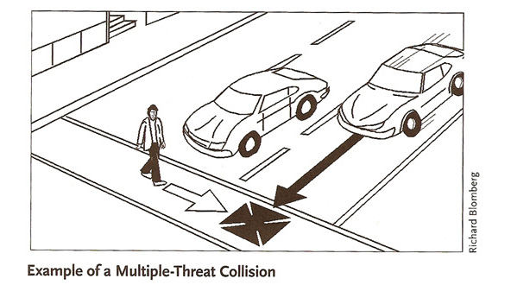
It is extremely importantly that students understand the dangers of crossing multiple lanes when there is a vehicle that has stopped to yield in only one lane, as shown in the illustration to the right (Barlow, Bentzen, Sauerburger & Franck, page 383). This is how Dick and Lorraine Evensen were killed.
In this situation, the presence of a vehicle waiting in one lane can reduce the visibility of the pedestrian to other drivers, and reduce the ability of the pedestrian to hear other approaching traffic. Hopefully the student is already aware of the effect of sounds being masked or blocked by other vehicles, and is aware that there may be vehicles approaching in other lanes.
Students should also understand that they can not trust the verbal assurance of drivers or others that it is safe to cross.

**Some of the statements are based on a single study and may therefore have limited application, others are more thoroughly researched. Regardless, none of the statements can reliably predict drivers' behavior in any given situation.

Likelihood of being hit may vary!
Many of these factors (such as road conditions and visibility, traffic speed, drivers' expectations, etc.) can vary greatly at any given crossing, so the likelihood that the approaching vehicles will hit you can also vary.

Page 5 of 14
Assess the Risk of the Crossing
If I am hit, how likely is it that I will be seriously injured or killed?

So far, we've discussed analyzing a given crossing in a given situation to determine whether you have the right of way and how likely it is that you will be hit by a vehicle if you cross. Now we consider the bottom line -- if you are hit, how likely is the injury going to be severe or fatal?
** Of course the main factor that determines the seriousness of the injury is the speed of the vehicle.
The chart below, from the National Highway Traffic Safety Administration (NHTSA), shows the severity of the injuries with drivers at various estimated speeds. NHTSA's publication also has a chart (Tables 2-4) showing severity of injury in crossings with various SPEED LIMITS (rather than the estimated actual speeds), which might be more helpful to you or your student because you don't need to estimate drivers' speeds at the crossing in order to estimate the probability of a severe injury. However keep in mind that the chart of injuries at streets with various speed limits doesn't explain how well the drivers obeyed those speed limits -- that is, we know the speed limit posted at the crossing but we don't know the range of actual speed of vehicles there at the time of the crash.

Vehicle travel speed and pedestrian injury severity (Florida, 1993-1996; pedestrian in single-car crashes)
 | Travel speed (officers' estimate)
Injury severity | 1-20 mph  0-32 kmh | 21-25 mph  33-40 kmh | 26-30 mph  41-48 kmh | 31-35 mph  49-56 kmh | 36-45 mph  57-72 kmh | 46+ mph  73+ kmh | TOTAL
Fatal | 1.1% | 3.7% | 6.1% | 12.5% | 22.4% | 36.1% | 6.5%
Incapacitating | 19.4% | 32.0% | 35.9% | 39.3% | 40.2% | 33.7% | 27.0%
Fatal or incapacitating | 20.5% | 35.7% | 42.0% | 51.8% | 62.6% | 69.8% | 33.5%
Non-incapacitating | 43.8% | 41.2% | 36.8% | 31.6% | 24.7% | 20.5% | 38.8%
Possible / no injury | 35.6% | 23.0% | 21.2% | 16.6% | 12.7% | 9.7% | 27.7%

National Highway Traffic Safety Administration (1999). Literature Review on Vehicle Travel Speeds and Pedestrian Injuries DOT HS 809 021

Page 6 of 14

Assess the Risk of the Crossing
Putting it all together!
We've talked about the variables to consider when determining the probable consequences of crossing in a given Situation of Uncertainty. These include the probability that you'll be surprised and then hit by a vehicle and if that happens, how likely your injury will be severe or fatal, and whether you have the right of way.
For example, if you are in a Situation of Uncertainty,
- the possibility that you will be surprised by a vehicle during your crossing is higher if there is more traffic and less warning of approaching vehicles (their detection-to-arrival time).
- If there IS an unexpected vehicle, the possibility that it will stop for you is higher when the drivers are going slowly, they have a good line of sight and good road conditions and are expecting pedestrians, there is only one approaching lane, and you have a white cane and are waiting with a foot in the street.
- If you ARE hit by an unexpected vehicle, the possibility that you will be severely injured or killed is higher when the vehicles are going fast.
- If you are crossing where you legally have the right of way because of the particular laws in your state, you might not expect that drivers will yield but you will have legal recourse if you are hit. On the other hand, even though you are legally permitted to cross where you don't have the right of way, you are required to yield to drivers there, so you may have no recourse if you are hit while crossing.
These variables should be considered in combination to assess the level of risk. Examples of weighing those factors are on page 13 of this section ("Want to apply this to real situations?") and Section 5, Vignette 3 (Considering risks").
Risk Analysis Checklist
I've developed a checklist to record the various factors to consider when analyzing risks of crossing in Situations of Uncertainty. The second page of the checklist (which can be printed on the back) shows a list of alternatives to consider if the risk of crossing is not acceptable (these are covered later in this Section). To download the checklist, click on the "Risk Analysis Checklist" link above.
NOTE: The checklist is attached at the end of this paper – the last two pages, ready to print.

Page 7 of 14
Is the crossing safe enough?
To cross, or not to cross -- that is the question!
We've talked about analyzing the level of risk of crossing in Situations of Uncertainty -- of course it can vary from extremely low risk to extremely high risk. So it seems simple -- once you've assessed the risk of crossing, you can decide whether it is safe enough to cross.

But [gulp] how in the world can we decide if something is safe enough to cross? According to Webster's dictionary, "safe" means "free from risk." Using that definition, nothing is safe, so how can we decide that it is safe enough to cross?
Well, thankfully there is a very functional definition used by industry to define when a product is "safe" for the market or a manufacturing process is "safe" for the workers. With this definition, it is easy to make a very clear distinction between what is "safe" and what is not. That definition is:
"A thing is safe if its risks are determined to be ?
What do you think would be a functional definition that clearly delineates which crossing situations are "safe" and which are not? Click here to guess or if you're too tired, go to the next page for the answer.

Page 8 of 14
Decide whether the risk is acceptable -- considerations
So -- now you know it is safe for you to cross when the risk is acceptable to you. Students will learn to assess the risk for each situation, and make informed and well-reasoned decisions as to whether it is acceptable to them, based on objective observations of the important factors.

Considerations
- Students who are too young to make these decisions will, at appropriate ages, learn the various concepts and skills they need to assess situations so that ultimately, they can make good street-crossing decisions.
- People often feel that the risk of crossing a given street is acceptable a certain times, and not at others. This is because the level of risk at each crossing can vary widely, based on variations in factors such as traffic volume and speed, pedestrians present, warning times, road conditions and visibility, etc. One example was explained beautifully by my client at the Situation of Uncertainty she encountered on her route to the swimming pool.
- The decision of whether the risk of crossing is acceptable may be affected by factors other than the level of risk. For example, in Scenario #3 on page 13, Carlo was not willing to accept the risk of crossing even though the level of risk was very low because he didn't feel comfortable having to deal with the unknown as he crossed.
- Sometimes people have to balance or choose among various considerations. For example if crossing at a particular unmarked crosswalk has a higher risk of being seriously injured or killed than crossing in the middle of the next block, the pedestrian will have to consider the benefits of having the right of way versus the risk of being hit.

"Is this crossing safe?"
Over the years I've learned that when I am teaching students to recognize Situations of Uncertainty and I ask them to analyze a crossing situation, I should avoid asking them if it would be "safe" for them to cross when I actually wanted to ask them if they can hear/(see) the traffic with enough warning to be confident that it's clear to cross. In Section 5, Vignette #2 ("Safety vs. Confidence") I tell the story about how I learned that asking people if it's safe to cross is very different from asking them if they can tell whether or not it is clear to cross.
Page 9 of 14

Decide whether the risk is acceptable
All that remains now is to talk about making the decision to cross or not to cross in a given situation -- a decision which depends on whether the risks of crossing are acceptable, of course.
The most common response I get when I ask adults whether the risk of crossing is acceptable is, "What choice do I have? I need to get to the store / my job / the bus." So sometimes, simply knowing that there are other choices can be empowering, and I assure my students that they never have to cross where they feel that the risk is not acceptable.
If they decide that in a given Situation of Uncertainty, it is safe enough to cross (and what does that mean again? It means "its risks are acceptable"!), then we consider what they can do to reduce the risks as much as possible. For example they might try to make themselves visible, use a cane, and of course cross when they can hear/(see) nothing coming (realizing that there could still be a car coming that would have to slow down for them).
If they decide that the risks of crossing in that situation are not acceptable, they consider alternatives. It is very important that our students not only know about alternatives, but can also find or plan for and use them effectively.

Page 10 of 14

Consider alternatives when the risk of crossing is not acceptable/preferable
When you find yourself in a Situation of Uncertainty and have determined that the level of risk of crossing is not acceptable, the last step in this process is to consider alternatives.
I use every opportunity to have students practice finding and using alternatives whenever we find a Situation of Uncertainty. If they say the risk of crossing there is acceptable, I always respect their decision and then I ask them if we can use this to practice considering alternatives anyway, because they will certainly find crossings with unacceptable risk some time in their lives. Sometimes, even though the risk of crossing is acceptable, they find alternatives that are preferable.
Every Situation of Uncertainty has at least one alternative to crossing -- if nothing else, there is always the alternative of simply turning around and not going where you intended to go. I remember one teenager who was having a horrible time getting to her destination because of risky or extremely difficult situations, and after more than an hour I came up to her and suggested she do whatever she'd do if she were not on a lesson. She said she would go back home, and that is what I suggested she do. I never encourage people to take risks that they are not comfortable with -- our students need to be empowered to honor and trust their own instincts, even if they differ from our own.
The next page has all the alternatives to crossing independently that I've accumulated over the years. If you can think of any alternative that isn't listed, I hope you'll let me know.

Page 11 of 14
Alternatives When Crossing is Too Risky
No one should ever have to assume more risk than they are willing to accept. So when the risk of independently crossing a street at a given time and place is too high, alternatives should be considered. This page features a list of such alternatives.
Please note that:
- all alternatives are not feasible for every situation, but with careful consideration and planning there is always at least one that can apply.
- some alternatives require years of planning (contacting the traffic engineer) and others can be implemented right away (getting help or crossing somewhere else).
- these alternative strategies can be used by deaf-blind people.

Alternatives:

Get help to cross

There are many creative and effective ways to get assistance, including recruiting drivers to get out of their vehicle and guide the person across, going to bus stops or public buildings to request assistance, or calling ahead or using a cell phone to request someone to come help cross.
Principles of getting help to cross streets:
- Face the street.
- Look like you want help (use a card, gestures, voice, etc. -- click here for suggestions for deaf-blind people to use a card to get assistance).
- Explain exactly what you want the other person to do.
- You can get help effectively from:
  - Passersby (go where most people go -- corners, bus stops, store entrances, etc.
  - Neighbors/shopkeepers (some people ask for assistance at nearby shops or friendly neighbors, others use their cell phone or call ahead and ask store or business personnel to watch for them and help them cross; one deaf-blind woman used a braille TTY to call a Seven-Eleven corner store whose employees agreed to watch for her and help her cross the street so she could get to the subway and go to work every day).
  - Drivers (hold up a sign with words "CROSS STREET" large enough for drivers to see, with more detail in smaller print if needed -- this works very well where drivers are going slowly and they have a place to pull over safely).
If you want to see videos of students (with and without a cane) using a sign to get help from drivers to cross the street, you can click here.

At streets where there is no traffic signal or stop sign, find a place to cross where you can hear/see the traffic better, and/or where you are more visible.

Sometimes the reason that you can't be confident it is clear to cross is that the sounds and/or line of sight are blocked by a hill or bend in the road, or a parked van, etc. In that case, you may be able to hear / see further by moving toward or away from the obstruction, such as moving to the bend or top of the hill, or moving away from the parked van, etc. (examples are in Vignette 4 and Vignette 5 of Section 5).

Cross at a place that has better traffic control (a traffic signal or stop sign).

In streets with multiple lanes going the same direction, you can often figure out if there is a traffic signal nearby by listening to the traffic. If the vehicles are bunched together in a "platoon" followed by gaps in traffic, there is usually a traffic signal upstream -- the closer the traffic is bunched, the closer is the traffic signal.

Increase the likelihood that drivers will yield

For example . . .
- carry a white cane;
- cross where drivers
  - are going more slowly
  - can see you better, and/or
  - are more likely to expect pedestrians to cross.
- make yourself more visible, for example at night wear bright reflective clothes, use a flashlight, etc. (NOTE, our research suggests that wearing an orange vest does NOT make the drivers more likely to yield).
- At intersections with traffic signals, use strategies that have been shown to increase yielding for the right-turning drivers, such as taking a reversible step and/or holding up the hand to indicate "stop."

Avoid crossing

Make plans to achieve your goal without crossing the street. For example,
- use rides and taxis, bus/paratransit, etc.
- if crossing the street to catch a bus, get on the bus on your side of the street and take it to the end of the line and back;
- shop on line or have home delivery.

Cross only after getting all drivers to yield

When the risk of crossing is unacceptable because drivers are likely to reach the crosswalk without yielding, one alternative is to cross when drivers in all approaching lanes have stopped for the pedestrian. This may be a viable alternative, for example, when crossing a single, separate right-turning lane.
However this strategy is safe and effective only when:
- the traffic has stopped in each approaching lane. Pedestrians should be aware of the great danger presented when drivers have stopped in at least one lane but not all of the lanes (see "multiple threats").
- it is possible to determine with certainty that drivers have stopped. This is not always possible for blind pedestrians to do -- they can be misled into thinking that drivers have stopped when they have not (see study). And blind pedestrians may not realize that drivers have stopped in noisy environments or when the drivers stop far from the crosswalk.

Under certain conditions at crossings with no traffic signal or stop sign, be prepared to return to curb

This alternative strategy is intended to help avoid the possibility of any vehicles being able to reach you during your crossing (click here to see the video) .
It can be effective ONLY IF
a. you can hear or see the traffic well enough to know whether it is clear to cross at least half the street;
AND
b. you know when you've crossed halfway; AND
c. you can turn around and return to the curb.
Strategy:
- If you're using hearing, wait until it is quiet (if you are using vision, wait until you see nothing coming), then start to cross.
- If you're using hearing and you hear a vehicle approaching from either direction before you reach the middle, or if you're using vision and see a vehicle approaching from the right before you reach the middle:
turn around and return to the curb, and wait for another opportunity to try again.
- If you reach the middle without hearing or seeing any vehicles approach, you can complete the crossing.

NOTES:
- This strategy is NOT to cross to the middle of the street and wait! In many situations, waiting in the middle of the street would be extremely dangerous. This strategy is to start to cross, but TURN AROUND and go back to the curb if you notice something coming before you reach the middle. If you reach the middle with nothing coming, keep walking and complete the crossing.
- You might ask why you should turn around if you hear a car coming from the left, when you know that you would be out of that car's path by the time it reaches you. It is because the sound of the car from the left may be masking the sound of another car coming from the right.
- Some examples of where this strategy might be effective (and where it would not be effective and why!) are at the end of each Scenario on page 13.

Request traffic engineer to revise or redesign the intersection

You can request that a stop sign or traffic signal be installed at the intersection, but these crossings can also be made significantly safer with relatively inexpensive redesign such as:
- Slow the traffic with raised crosswalks or humps;
- install bulbouts (the sidewalk protrudes into the street, often cutting off a lane and designating it for parking -- this shortens the crosswalk and slows the traffic);

The next page shows photos of these designs.

Page 12 of 14

Alternatives When Crossing is Too Risky
Environmental Modifications to Improve Crossings with No Traffic Control
The design of crossings with no traffic signal or stop sign can be altered to make them easier and safer by shortening the distance to cross, slowing down the traffic, and increasing the likelihood that drivers will yield.
A great resource showing suggestions for design improvements, based on research to increase the likelihood that drivers will yield to pedestrians at these crossings, is

Improving Pedestrian Safety at Unsignalized Crossings: Appendices B to O
(from the 2006 TCRP Report 112/NCHRP Report 562 - Improving pedestrian safety at unsignalized crossings; Transit Cooperative Research Program and National Cooperative Highway Research Program, Washington, D.C.: Transportation Research Board).

Meanwhile, photos of some examples I've seen are shown below:

Horizontal deflection:
Traffic can be slowed by requiring it to move right or left rather than go straight -- the tighter the turn required, the slower the traffic. Features that can deflect the traffic include islands, circles, and bulbouts (bulbouts are extensions or "bumpouts" of the sidewalk or curb into the street).
BULBOUTS, CIRCLES and REFUGE ISLANDS

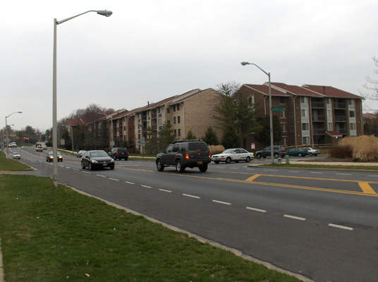
Example 1 --
At the street shown here, it was impossible to hear the vehicles far enough away to know whether it was clear to cross all 5 lanes. A blind man who had to cross it with his young son to catch the bus decided it was too risky.
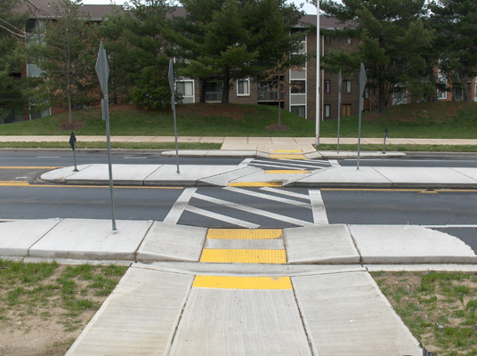
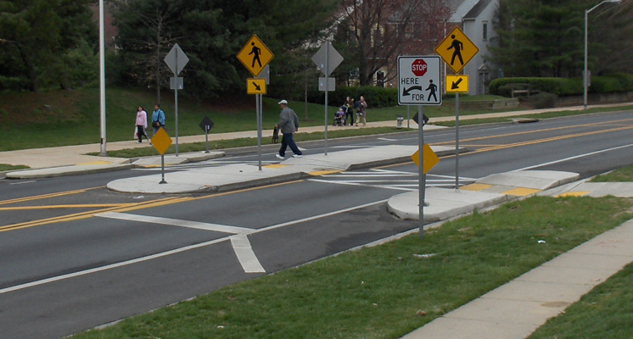
Several years later, this same street was made much safer for pedestrians by converting the outside lanes to parking lanes and cutting them off with bulbouts (sidewalk extending into the street), and filling in the middle (turning) lane with a refuge island. Pedestrians only have to cross one lane at a time.

The above photos show the same crosswalk. The cut-through of the refuge island is at an angle, to encourage pedestrians to face the oncoming traffic before crossing
Example 2 --
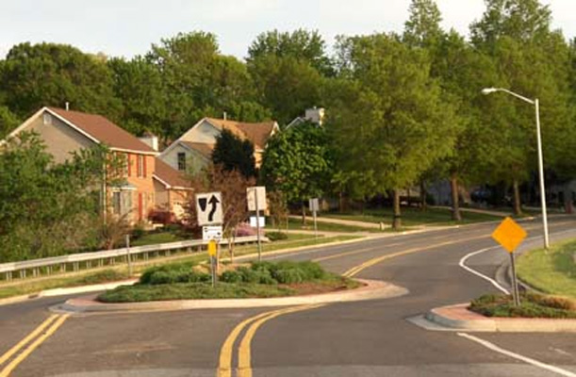
These photos all show a 3-lane, moderately busy residential through-street where a small circular island and two bulbouts were installed to deflect the traffic, making vehicles turn and slow down.
The photo (below left) is the way it looks now and (below right) the photo has been revised to show how it looked before the circle and bulbouts were installed.

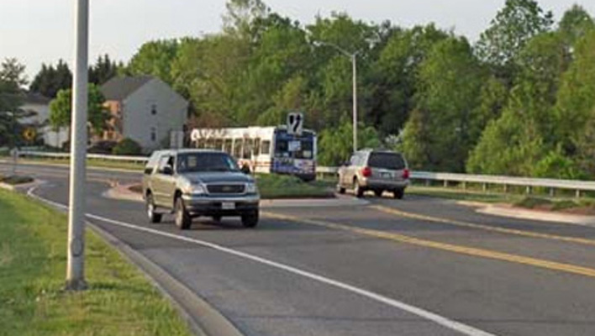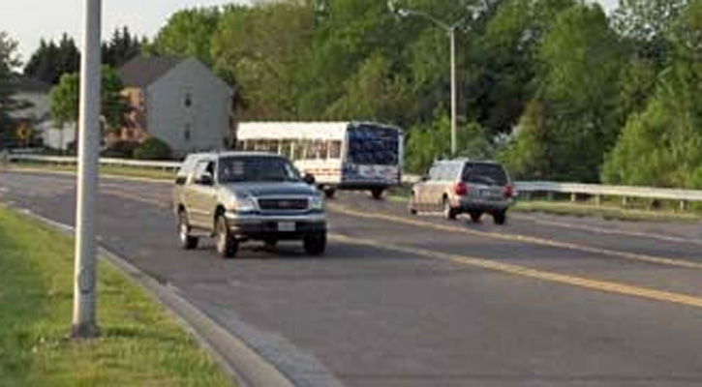

Example 3 --
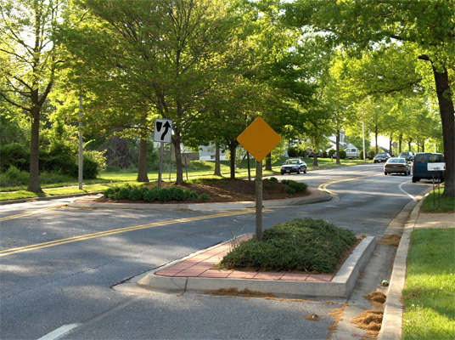
A circle and bulbouts were installed in the street in the photo to the left.

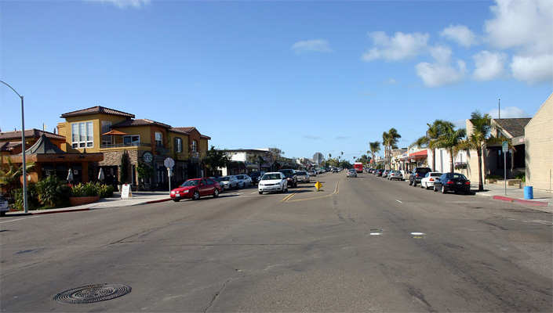
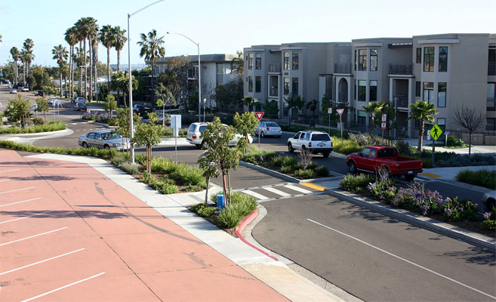
Example 4 --

(Above) La Jolla Boulevard in San Diego was 80 feet curb to curb before it was redesigned, the crosswalk is now 13 feet curb to curb. Concept by Michael Wallwork, P.E., Alternate Street Design. P.A.

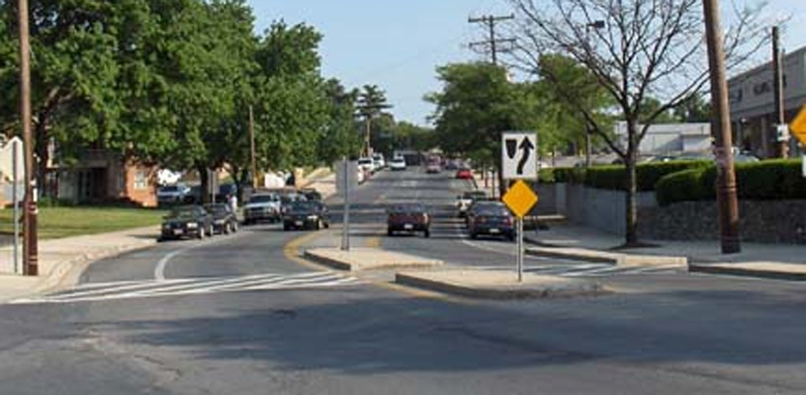
Example 5 –

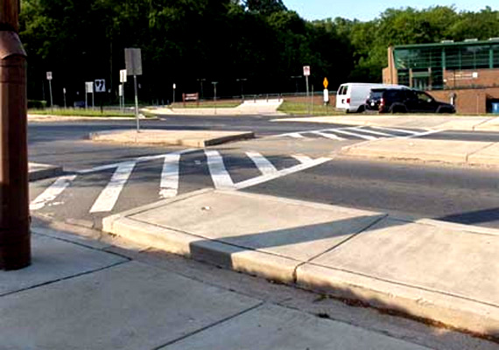

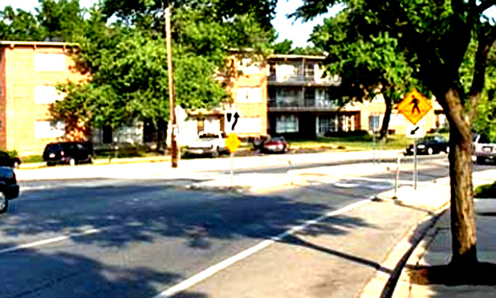

These three photographs show a crosswalk that was shortened with a bulbout on one side of the street and a pedestrian refuge island in the middle. However detectable warnings should be installed to help blind pedestrians recognize the areas of refuge.

ROUNDABOUTS

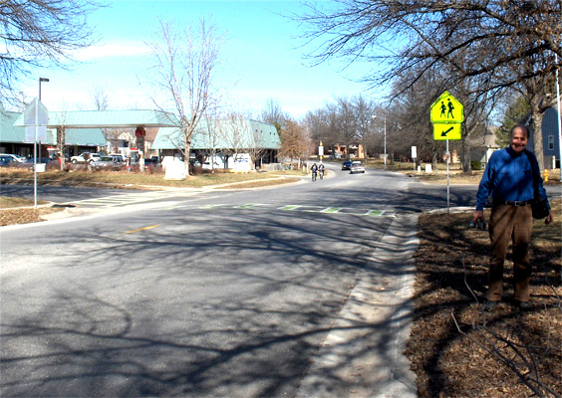

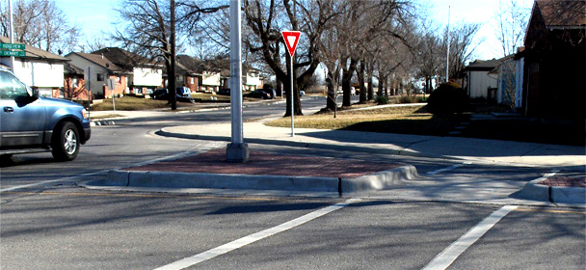
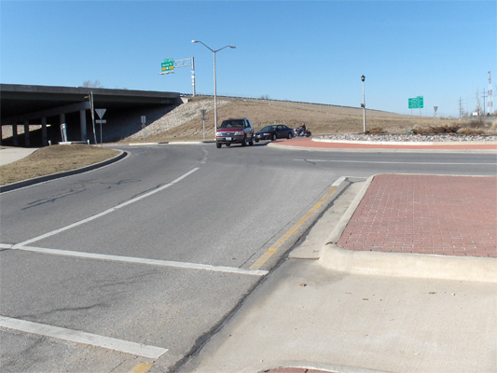
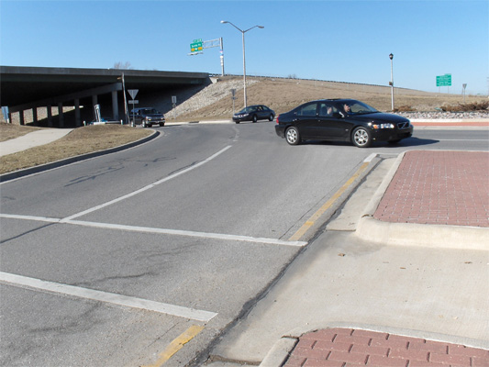
For some reason, it is not possible to hear the approaching cars at this crosswalk in Olathe, Missouri (left) well enough to know whether it is clear to cross, even when it is quiet.
A half block away on the same street, a one-lane roundabout was installed (left). The tight radius slows the traffic, and splitter islands divide the crosswalk into two short crossings. When it is quiet there, it possible to hear the cars well enough to know whether it is clear enough to cross to/from the splitter island. However, if there are not sufficient gaps in traffic to allow it to become quiet, it may still not be possible to recognize when it is clear to cross.
Roundabouts are not necessarily the solution, however, if they are not designed well, and/or if they are in a noisy environment or traffic is too heavy to provide crossable gaps in traffic. The photos below show a roundabout that was installed a block away from the quiet roundabout shown above. This roundabout is two lanes wide so the crosswalks are twice as long, the turning radius is large enough that the traffic can maintain higher speeds, and loud, constant noise from the highway on the bridge nearby makes it impossible to hear approaching traffic until it is a few seconds away. Thus, if a blind person heard nothing coming and stepped out to cross, there could be a car only seconds away from impact.
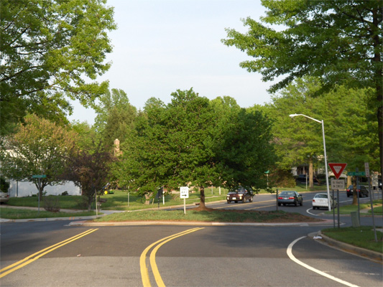
CIRCLES

Shown here is a circle in the middle of the intersection, which slows down the traffic because the circle is large enough to block straight-through vehicles and require them to turn into the perpendicular street before resuming their direction.

Vertical deflection:

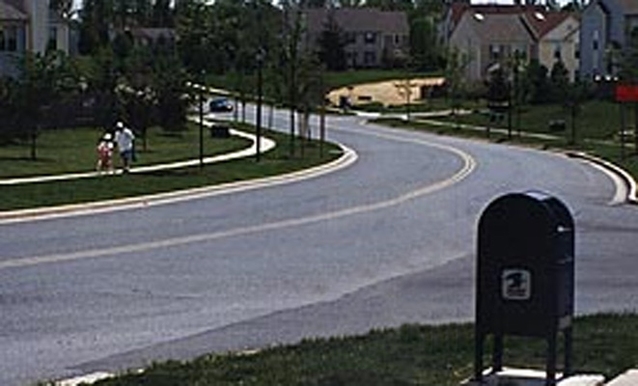
SPEED HUMPS
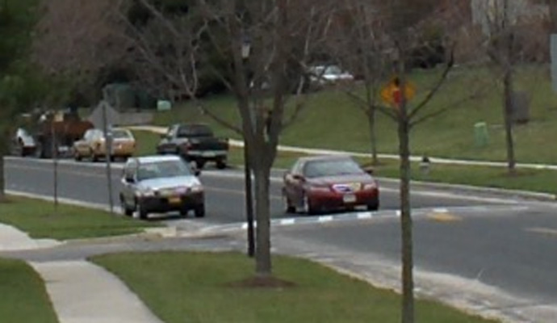
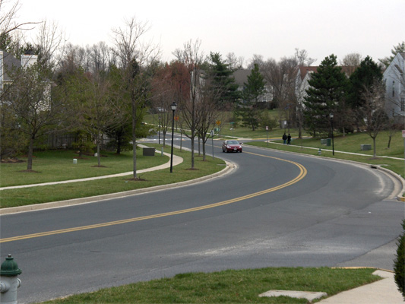
When the photo on the right was taken in 1994, it was not possible to hear all the approaching cars well enough to know if it was clear to cross, even when quiet (see "Challenge Photo #5").
The photo below shows the same intersection today. Now, when it is quiet, the cars can be heard with enough warning. The difference?
A speed hump which had been installed almost out of sight around the bend (above) slows the traffic and makes it possible to hear them with more warning.

Page 13 of 14
Want to apply this to real situations?
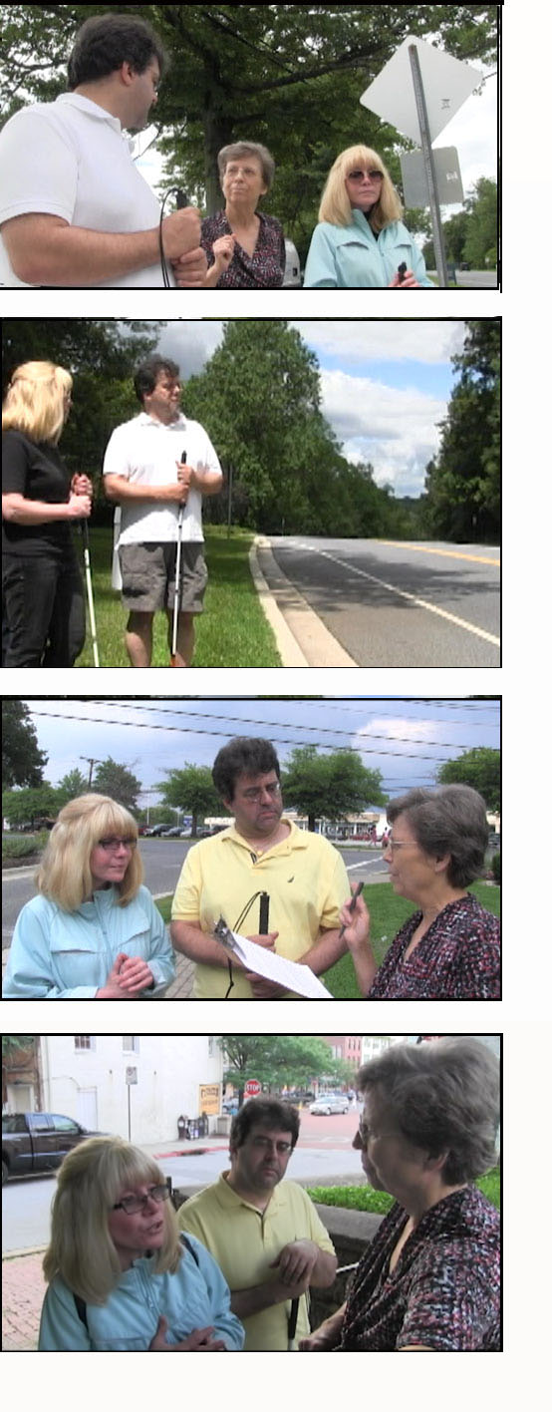
If you'd like to process what you've learned about analyzing risks, making decisions and considering alternatives by applying it to real situations, this page is for you! If not, feel free to move to the next page -- you can always come back later and play.
What's this all about?
While developing a project for the American Printing House for the Blind, I asked Carlo and Cecilia, two independent travelers who are blind and have normal hearing, to analyze the risks of crossing in three different Situations of Uncertainty. I chose a variety of situations to reveal the complexity of factors that can affect the analysis, which lead to some surprising results and illustrated the importance of being methodical when considering the risks.
Before we began the analysis, I explained to Carlo and Cecilia all the factors in the Risk Analysis Checklist. At each crossing, they observed the traffic and how well they could hear it and, if the street was not familiar, they figured out how wide it is. Then we went through each item on the checklist and they came up with their analysis of the situation, as well as which alternatives might be feasible. In each case, we did not consider factors that might have existed at other times of the day, such as what might happen at night or during rush hour -- it is important to be able to analyze situations that exist at the time that you consider crossing.
Regarding whether the risks of crossing are acceptable, there is no right or wrong answer -- that is a personal choice. In the third scenario you'll see that the decision of accepting risk may differ between people, and it may not even be directly related to the level of risk. What is important is that the decision is informed and well-reasoned, based on objective observations of the important factors that exist at the time the decision is made.

Scenarios
Below are videos from the three Situations of Uncertainty, with explanations of the warning time that they had, followed by the results of the analysis by Carlo and Cecilia. You can either simply read through their analyses, or analyze the situations yourself.
To get some experience analyzing situations yourself: Scroll down to each scenario, read about the "Warning time of approaching vehicles" and click on the link to watch the video for that situation. Fill out the Risk Analysis Checklist, and see how your analysis compares to those of Carlo and Cecilia.

Scenario #1: Clearwater

WARNING TIME OF APPROACHING VEHICLES:
For traffic from the left, there was more than enough warning to be confident it is clear to cross when quiet. From the right there was almost but not quite enough warning of approaching traffic, so it was not possible to be confident that it was clear to cross.
- Click here to see the video
- Click here for a written description of the video
.
ANALYSIS:

Would Cecilia and Carlo have the right of way at this crossing?
Yes -- it was clearly marked as a crosswalk for pedestrians.
Likelihood that they'd be surprised by an approaching vehicle if they started to cross when quiet: unlikely
- Reasoning: Since they had enough warning for vehicles from the left and almost enough for vehicles from the right, when it was quiet the area where a vehicle could be close enough to reach them but not close enough to be heard was small.
So even though traffic volume was moderately high, they considered it unlikely that if they started to cross when it's quiet, there would be an approaching vehicle just out of earshot that could reach them.

If they were surprised, likelihood that the driver would hit them: moderately to extremely unlikely
Factors that indicated the drivers would not be likely to stop for Carlo or Cecilia:
- Vehicles were going moderately fast;
- Carlo and Cecilia would not be likely to cross with a group of pedestrians.
Factors that indicated the drivers would be likely to stop:
- There was only one lane approaching in each direction (no "multiple threats")
- Pedestrians were highly expected (crosswalk was very well marked and pedestrians crossed frequently);
- Line of sight and visibility were good and the warning time of approaching vehicles was relatively long, so they would not be likely to start their crossing when the driver is too close to avoid hitting them;
- Road conditions were good;
- They could safely stand with a foot in the street to wait to cross;
- They'd be using a cane;
- Drivers were observed to stop for most pedestrians.

If they were hit, likelihood of being seriously injured or killed: about 52%
- vehicles were going about 30-35 mph (see chart on page 5, or look at the bottom of the front page of your checklist)

Summary: Risk of being seriously injured or killed is relatively low.
If Carlo or Cecilia started to cross when it's quiet, it is unlikely they'd be surprised by an approaching vehicle that could reach them and if that happened, it is very unlikely that it would hit them but if it did, they'd have a relatively high (about 50/50) chance of being seriously injured or killed.

Is the risk acceptable?
Carlo and Cecilia both felt that the risk of crossing in that situation was acceptable.
Feasible alternatives if the risk of crossing was not acceptable:
- Get assistance (there are lots of pedestrians crossing who could help).
- Cross at another location with better control (there is a traffic signal about a block away).
- Get all the drivers to yield: Since there is only one lane in each direction and a refuge island in the middle, they could wait to cross each half of the street until a driver had stopped for them.
- Avoid the crossing, for example by getting a ride.
- QUESTION: Does this meet the conditions to be able to use the alternative of being prepared to turn around and return to the curb? (Click here for the answer)

Scenario #2: Truman Parkway

WARNING TIME OF APPROACHING VEHICLES:
Because of constant ambient sounds from a nearby highway, the vehicles from both directions could not all be heard with enough warning to be confident it was clear to even reach the middle of the street.
- Click here to see the video
- Click here for a written description of the videos.

ANALYSIS:
Would Cecilia and Carlo have the right of way at this crossing?
No -- This was a mid-block crossing, the only corner nearby was the entrance to a parking lot. However in states where pedestrians with white canes have the right of way everywhere, Carlo and Cecilia would have had the right of way here.
Likelihood that they'd be surprised by an approaching vehicle if they started to cross when quiet: likely
- Reasoning: traffic volume was moderately high and since the approaching vehicles couldn't be heard with enough warning to get even half way across the street, the area where a vehicle could be close enough to reach them but not close enough to be heard was relatively large.

If they were surprised, likelihood that the driver would hit them: very likely
Factors that indicated the drivers would not be likely to stop for Carlo or Cecilia:
- there were two lanes approaching from the right so there was the possibility of "multiple threats;"
- vehicles were going fast;
- pedestrians would be completely unexpected (no pedestrians were ever seen crossing there);
- line of sight was not good from the left and, even from the right, it's possible Carlo or Cecilia could have started their crossing when the drivers were close because the warning time of approaching vehicles was short.
- they would not be likely to cross with a group of pedestrians, and they would not be comfortable waiting with their foot in the street.
Factors that indicated the drivers would be likely to stop:
- road conditions were good;
- they'd be using a cane.

If they were hit, likelihood of being seriously injured or killed: about 62%
- vehicles were going about 40 mph (see chart on page 5, or look at the bottom of the front page of your checklist)

Summary: Risk of being seriously injured or killed is very high.
If Carlo or Cecilia started to cross when it's quiet, it is likely they'd be surprised by an approaching vehicle that could reach them and if that happened, it is very likely that it would hit them and if it did, they'd have about a 62% chance of being seriously injured or killed.
Is the risk acceptable?
Carlo and Cecilia both felt that the risk of crossing in that situation was definitely NOT acceptable.
Feasible alternatives if the risk of crossing was not acceptable:
- Look for another location with better control or where they are more visible to the drivers and they can hear the approaching vehicles with more warning, or where drivers expect more pedestrians.
- Figure some way to avoid the crossing, such as getting a ride.
- Request environmental modifications adding bulbouts and a refuge island to change the 4-lane crossing into two one-lane crossings, like the first example on page 12.
- QUESTION: Does this meet the conditions to be able to use the alternative of being prepared to turn around and return to the curb? (Click here for the answer)

Scenario #3: Main Street, Annapolis

WARNING TIME OF APPROACHING VEHICLES:
It was not possible for Cecilia or Carlo to hear any of the approaching vehicles until they were just a few seconds away, and in some cases there was NO warning of the approaching vehicles because they couldn't be heard even when they were IN the crosswalk!
Note: Can you speculate why it was so hard to hear the vehicles? Think about the residual sound level of "quiet" in most cities, and consider how much noise the vehicles would make when they are moving slowly (quiet cars may not even be audible at that speed).
- Click here to see the video
- Click here for a written description of the videos.

ANALYSIS:

Would Cecilia and Carlo have the right of way at this crossing?
Yes -- The crosswalk was well marked, and in most states it would be considered a crosswalk even if it hadn't been marked.
Likelihood that they'd be surprised by an approaching vehicle if they started to cross when quiet: extremely likely
- Reasoning: very high traffic volume (almost always a vehicle was approaching) and there was almost no warning of approaching vehicles (some passed by without being heard at all!)

If they were surprised, likelihood that the driver would hit them: extremely unlikely
Factors that indicated the drivers would not be likely to stop for Carlo or Cecilia:
- there was more than one lane approaching so there was the possibility of "multiple threats;"
Factors that indicated the drivers would be likely to stop:
- traffic is extremely slow;
- pedestrians were highly expected (crosswalk was marked and many pedestrians crossed there);
- Line of sight, visibility and road conditions were good;
- They could safely stand with a foot in the street to wait to cross;
- They'd be using a cane;
- observation of the drivers demonstrated a high willingness to stop (pedestrians never had to wait for the drivers);
Note: Even though there were many groups of pedestrians crossing, Carlo and Cecilia didn't consider this a factor because they weren't sure they'd be in a group when they crossed.

If they were hit, likelihood of being seriously injured or killed: less than 20%
- Vehicles were going about 5-10 mph, which put them in the chart's first category (see chart on page 5, or look at the bottom of the front page of your checklist). That category included traffic moving as fast as 20 mph, so they figured the likelihood of being seriously injured or killed by these vehicles was less than the percentage indicated in the chart.

Summary: Risk of being seriously injured or killed is very low.
Although it is extremely likely that they would be surprised by a vehicle approaching the crosswalk which could reach them if they start to cross when it's quiet, when that happens it is extremely unlikely that the vehicle would hit them and if it did, the chance that they'd be seriously injured or killed is less than 20%.
Is the risk acceptable?
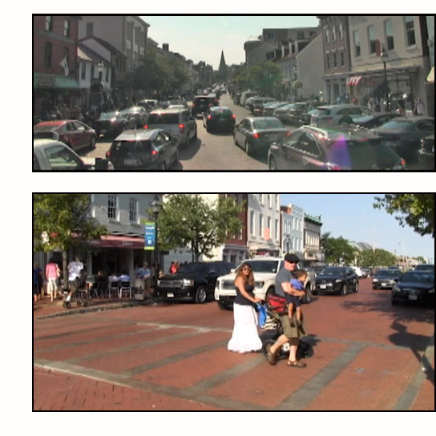
Cecilia felt that the risk of crossing in that situation was acceptable, but Carlo did not. It would be very likely that when he started the crossing, vehicles would be in the crosswalk or approaching it, and he didn't like crossing without being able to know what was happening around him.
Feasible alternatives if the risk of crossing was not acceptable:
- get assistance (there are lots of pedestrians crossing who could help)
- cross at another location where there is a traffic signal or where they can hear better:
As Main Street goes up the hill it becomes more narrow, and lanes are blocked for parking, as shown in the first picture to the right (taken from the middle of the crosswalk that was assessed). A block away the street is half as wide and it is possible to hear traffic better (shown in the second photo), and at the top of the hill (about two blocks away) is a traffic signal.
- Figure some way to avoid the crossing, such as getting a ride.
- QUESTION: Does this meet the conditions to be able to use the alternative of being prepared to turn around and return to the curb? (Click here for the answer.)

Reflections:
These situations were chosen because they presented so much variety! No two situations had the same features:
- Situation 1 was the only one where the likelihood of being surprised by an approaching vehicle was low;
- Situation 2 was the only one where the likelihood that drivers would yield was low; and
- Situation 3 was the only one where the likelihood was low that if you were hit, you'd be seriously injured or killed.
Were you surprised that the situation that had the least warning of approaching vehicles was not the one with the highest risk? No single factor can predict whether or not the risk will be high -- to analyze situations, we need to look at and weigh all the factors.

Page 14 of 14
Review

Congratulations, you've finished Section 3! We've learned that when you find yourself at a crossing in a Situation of Uncertainty you:

assess the risk of the crossing by considering:
- who has the right of way here? (understand pedestrian and white cane laws)
- how likely is it that am I going to be surprised by an unexpected vehicle?
Depends on:
  - how much traffic is there?
  - how much warning time (detection-to-arrival time) do I have for approaching vehicles?
- if I am surprised by an unexpected vehicle, how likely is it that it will hit me?
Considering drivers' speed, sight distance and expectations, multiple threats, use of cane, etc.
- if I am hit, how likely am I going to be seriously injuried or killed?
Considering the drivers' speed.

Decide whether the risk is acceptable;
Considering the meaning of "Safe"

Consider alternatives when the risk of crossing is not acceptable (or is not preferable).
- Get help to cross;
- Find a crossing where you can hear/see the traffic better or are more visible;
- Cross at a traffic signal or stop sign;
- Increase the likelihood that drivers will yield OR get all the drivers to stop before you start crossing;
- Avoid crossing;
- Be prepared to return to curb;
- Request traffic engineer to revise or redesign the intersection.

ATTACHED (next two pages)
is the Risk Analysis Checklist
and the
list of Alternatives
RISK ANALYSIS for Situations of Uncertainty

Site: __________________Date/time of day:____________

1. Do you have the right of way to cross there? ____ yes _______ no

2. What is the likelihood of being seriously injured or killed if you cross under these conditions? ________
Use charts below to analyze likelihood of being surprised, then hit AND seriously injured or killed:

a. SURPRISED: Likelihood of being surprised by a vehicle that could reach you during your crossing?

Factor | Conditions
Traffic volume (higher volume = higher risk of being surprised)
Warning time of approaching vehicles
(longer warning time = lower risk of being surprised)
LIKELIHOOD OF BEING SURPRISED (high / moderate / low)

b. HIT: If you are surprised by a vehicle that could reach you, what is the likelihood that it will hit you?

Factor  Affecting likelihood of being hit | More likely | Likelihood moderate | Less likely
MULTIPLE THREAT: More than one approaching lane  (“yes” = drivers may pass another vehicle and hit you without seeing you) | Yes |  | No
SPEED of drivers: (slower = less likely to hit you) | Fast | Moderate | Slow
EXPECTATION: Drivers expect pedestrians? (“yes”= less likely) | No | Somewhat | Yes
VISIBILITY: Good line of sight / visibility? (“yes” = less likely) | No | Fair | Yes
ROAD CONDITIONS? (“good” = less likely to hit you) | Bad | Fair | Good
GROUP OF PEDESTRIANS crossing with you? (“yes” = less likely) | No |  | Yes
WAITING WITH FOOT IN THE STREET? (“yes” = less likely) | No |  | Yes
USING A CANE? (“yes” = less likely that drivers will hit you) | No |  | Yes
DRIVERS: community/culture (inc. observations of yielding there)
LIKELIHOOD OF BEING HIT (high / moderate / low)

c. SERIOUSLY INJURED OR KILLED? If you’re hit, how likely will you be seriously injured/killed?

Vehicle travel speed and pedestrian injury severity (Florida, 1993-1996; pedestrian in single-car crashes)
 | Travel speed (officers' estimate)
Injury severity | 1-20 mph  0-32 kmh | 21-25 mph  33-40 kmh | 26-30 mph  41-48 kmh | 31-35 mph  49-56 kmh | 36-45 mph  57-72 kmh | 46+ mph  73+ kmh | TOTAL
Fatal | 1.1% | 3.7% | 6.1% | 12.5% | 22.4% | 36.1% | 6.5%
Incapacitating | 19.4% | 32.0% | 35.9% | 39.3% | 40.2% | 33.7% | 27.0%
Fatal or incapacitating | 20.5% | 35.7% | 42.0% | 51.8% | 62.6% | 69.8% | 33.5%
Non-incapacitating | 43.8% | 41.2% | 36.8% | 31.6% | 24.7% | 20.5% | 38.8%
Possible / no injury | 35.6% | 23.0% | 21.2% | 16.6% | 12.7% | 9.7% | 27.7%

Alternatives if the risk of crossing is not acceptable

- Get help to cross (pedestrians, drivers, store/business personnel, neighbor, bus passengers, etc.).
- Find a place where you can hear/see the traffic better, and/or you are more visible.
- Cross at a place that has better traffic control (a traffic signal or stop sign).
- Increase the likelihood that drivers will yield OR
get drivers to yield (in ALL lanes!)
- Avoid the crossing.
- Under certain conditions, you can start to cross but return to curb if you hear something before you reach the middle of the street.
Conditions:
- Enough warning of approaching vehicles to be confident you have time to cross at least half the street
- Able to determine when you have crossed at least half the street
- Able to turn around quickly and effectively and return to crosswalk
- Request traffic engineer to revise or redesign the intersection.

